**DESIGN AND DEVELOPMENT OF A WEB APPLICATION:**

**ONLINE CLASS TALK**

**BY**

**SYEDA TASFIA HOSSAIN**

**ID: 171-15-8581**

**ALKUMA AKTHER MUNNA**

**ID: 171-15-8582**

**AND**

**SAKIB UDDIN AHMED**

**ID: 171-15-8782**

This Report Presented in Partial Fulfillment of the Requirements for the Degree of Bachelor of Science in Computer Science and Engineering.

Supervised By

**Mr. Narayan Ranjan Chakraborty**

Assistant Professor

Department of CSE

Daffodil International University

Co-Supervised By

**Md. Tarek Habib**

Assistant Professor

Department of CSE

Daffodil International University



**DAFFODIL INTERNATIONAL UNIVERSITY**

**DHAKA, BANGLADESH**

**DECEMBER 2020**

**APPROVAL**

This Project titled **“Online Class Talk”**, submitted by Sakib Uddin Ahmed**,** Alkuma Akther and Syeda Tasfia Hossain to the Department of Computer Science and Engineering, Daffodil International University, has been accepted as satisfactory for the partial fulfillment of the requirements for the degree of B.Sc. in Computer Science and Engineering and approved as to its style and contents.

**BOARD OF EXAMINERS**

**(Name)** [**Font-12, Bold**] **Chairman**

**Designation**

Department of CSE [**Font-12**]

Faculty of Science & Information Technology

Daffodil International University

**(Name) Internal Examiner**

**Designation**

Department of CSE

Faculty of Science & Information Technology

Daffodil International University

**(Name) External Examiner**

**Designation**

Department of -------

Jahangirnagar University

**DECLARATION**

We hereby declare that; this project has been done by us under the supervision of **Mr. Narayan Ranjan Chakraborty, Assistant professor, Department of CSE**Daffodil International University. We also declare that neither this project nor any part of this project has been submitted elsewhere for the award of any degree or diploma.

**Supervised by:**

**Mr. Narayan Ranjan Chakraborty**

Assistant Professor

Department of CSE

Daffodil International University

**Co-Supervised by:**

**Md. Tarek Habib**

Assistant Professor

Department of CSE

Daffodil International University

**Submitted by:**

**Sakib Uddin Ahmed**

ID: 171-15-8782

Department of CSE

Daffodil International University

**Alkuma Akther Munna**

ID: 171-15-8582

Department of CSE

Daffodil International University

**Syeda Tasfia Hossain**

ID: 171-15-8581

Department of CSE

Daffodil International University

**ACKNOWLEDGEMENT**

First, we express our heartiest thanks and gratefulness to almighty ALLAH for his divine blessing makes us possible to complete our final year project successful. But there are others, without their support, encouragement and appreciation we would not be able to bring our project into light of success. We, from the core of our heart, want to thank them all.

We want to thank our honorable **Supervisor Mr. Narayan Ranjan Chakraborty, Assistant Professor,** Department of Computer Science & Engineering, Daffodil International University**.** Deep knowledge and keen interest of our supervisor in the field of “Database management system” to carry out this project. His endless patience, encouragement, expert advice and above all his friendly behavior towards us have made it possible to complete this project.

We would like to express our heartiest gratitude to **Dr. Syed Akhter Hossain, Professor and Head**, Department of CSE, for his kind help to finish our project and also to other faculty member and the staff of CSE department of Daffodil International University.

Next, we must thank and acknowledge our university, Daffodil International University. We also want to thank our beloved classmates and other students of the university who took part in research purpose for our project and appreciated our work.

Lastly, we want to thank our beloved families, who were always by our side and kept faith on us. Without our family support, we could never be here, we cordially thank them for this. We also thank our friends for their support and help to us.

**ABSTRACT**

In this project, we have built up a web-based with different types of necessary features and unique features. The purpose of our project “ONLINE CLASS TALK” is easier to communicate with students and teachers. It saves students time and expenses. Students can virtually contact their teachers. For any kind of confusion at the selected course, they can solve with the help of this system quite easily. It provides an answer to collaborative learning for the students. Our management system is actually for teachers and students. They can view, download lectures provided by teachers. As per the title name Online Class Talk so the purpose of this system is to help the education system. Students and Teachers can create a post, comment. Students don’t need to meet physically with teachers. Our project's special feature is a chatting system. We used JAVASCRIPT, HTML, and CSS to design this website. After finishing our website, we also implemented an Android application to make it more user friendly. In the wake of finishing all tasks, the website and application tested in various stages and was discovered working effectively.

|  |  |  |
| --- | --- | --- |
|  | **TABLE OF CONTENT** |  |
| **CONTENT** | | **PAGE** |
| Approval | | i |
| Declaration | | ii |
| Acknowledgements | | iii |
| Abstract | | iv |
| **CHAPTER 1: INTRODUCTION** | | 1-3 |
| 1.1 | Introduction | 1 |
| 1.2 | Motivation | 1 |
| 1.3 | Objectives | 2 |
| 1.4  1.5 | Expected Outcomes  Project Management and Finance | 2  2 |
| 1.6 | Report Layout | 3 |
| **CHAPTER 2: BACKGROUND** | | 4-5 |
| 2.1 | Preliminaries | 4 |
| 2.2 | Related Works | 4 |
| 2.3 | Comparative Studies | 4 |
| 2.4  2.5 | Scope of the problem  Challenges | 4  5 |
| **CHAPTER 3: REQUIREMENT SPECIFICATION** | | 6-16 |
| 3.1 | Business Process Modeling | 6 |
| 3.2  3.2.1  3.2.2 | Requirement Collection and Analysis  Hardware and Software Requirement  Analysis | 7  7  7-8 |
| 3.3 | Use Case Modeling and Description | 8-9 |
| 3.4  3.5  3.6  3.7  3.8 | UML Object Diagram  Data Flow Diagram  Activity Diagram  Entity Relationship Diagram  Design Requirement | 9-10  11-13  14  15  16 |
| **CHAPTER 4: DESIGN SPECIFICATION** | | 17-20 |
| 4.1  4.1.1  4.1.2  4.1.3  4.1.4  4.1.5  4.2  4.2.1  4.2.2  4.3  4.4 | Front-end Design  HTML: Hyper Text Markup Language  Java-Script  CSS: Cascading Style Sheet  jQuery  Bootstrap  Back-end Design  PHP  MySQL  Interaction Design and User Experience (UX)  Implementation Requirements | 17  17  17  18  18  18  18  18  19  19  20 |
| **CHAPTER 5: IMPLEMENTING AND TESTING** | | 21-30 |
| 5.1 | Implementation of Database | 21 |
| 5.2  5.2.1  5.2.2  5.2.3  5.2.4  5.2.5  5.2.6  5.2.7  5.2.8  5.2.9  5.2.10  5.2.11  5.2.12  5.2.13  5.2.14  5.2.15  5.2.16 | Implementation of Front-end Design  Homepage of Class Talk  Login with Google  Class List of Class Talk  Join Class of Class Talk  Create Class  Homepage of Class  Class Work of Class Talk  Classmates of Class Talk  Classmates Profile  Message with Students and Teacher  Submit Class Assignment  Create Assignment by Teacher  View Assignment  Grading System of Class Talk  Create Group by Teacher  Class Details | 22  22  23  23  24  24  25  25  26  26  27  27  28  28  29  29  30 |
| 5.3  5.4 | Testing Implementation  Test Result & Report | 30  30 |
|  |  |  |
| **CHAPTER 6: IMPACT ON SOCIETY, ENVIRONMENT AND SUSTANIBILITY** | | 31-32 |
| 6.1  6.2 | Impact on Society Goal  Impact on Environment | 31  31 |
| 6.3  6.4 | Ethical Aspects  Sustainability Plan | 31-32  32 |
| **CHAPTER 7: CONCLUSION AND FUTURE SCOPE**  7.1 Discussion and Conclusion  7.2 Scope for Further Developments  **REFERENCES** | | 33  33  33  34-35 |

**LIST OF FIGURES**

**FIGURES PAGE NO**

Fig: 3.1 Business Process Modeling 6

Fig: 3.3 Use Case Modeling 8-9

Fig: 3.4 UML Object Diagram 9-10

Fig: 3.5 Data Flow Diagram 11-13

Fig: 3.6 Activity Diagram 14

Fig: 3.7 Entity Relationship Diagram 15

Fig 4.2.2: Database table list 19

Fig 5.1: Database table list 21

Fig 5.2.1 Homepage 22

Fig 5.2.2 Google Login 23

Fig 5.2.3 Class List 23

Fig 5.2.4 Join Class 24

Fig 5.2.5 Create Class 24

Fig 5.2.6 Homepage of Class 25

Fig 5.2.7: Classwork 25

Fig 5.2.8 Classmates 26

Fig 5.2.9 Classmate Profile 26

Fig 5.2.10 Messaging 27

Fig 5.2.11 Submit Assignment 27

Fig 5.2.12 Create Assignment 28

Fig 5.2.13 View Assignment 28

Fig 5.2.14: Grade system of Class Talk 29

Fig 5.2.15 Create Group 29

Fig 5.2.16 Class Details 30

**CHAPTER 1**

**INTRODUCTION**

* 1. **Introduction**

This project is a website for the Educational System in Bangladesh. We are trying to make a platform so that users can easily connect to the online class. This website will help the students to make their online classes easier. Online Class Talk System will also help the teacher and students to let them know about the information of the desire subject in an online system. There is a new feature which is the chatting system. Users can know about the information of every registered class. It saves students time and expenses. Students can virtually contact their teachers. For any kind of confusion at the selected course, they can solve with the help of this system quite easily. It provides an answer to collaborative learning for the students. After making the website we will make an android application related to our site so that it can be more user friendly. There are no such websites or applications till now in Bangladesh.

* 1. **Motivation**

For users-

Our web application's main motive is to reduce teacher's and student's sufferings by creating an online educational platform. By using our application one can easily get the counseling facility of their teacher. They can fix their meeting and solve their problems by using the chatting system. Students do not need to meet with their teacher physically. It will save peoples valuable time. Sometimes teachers use different applications to create a group chat and it creates confusion among some students. There is a chance to miss information because of using many applications. Our motive is to create a platform, where everything will be controlled under one application. This application will be very useful in any pandemic situation and people can continue their study online.

**1.3 Objectives**

Using this system users will be able to know about their Online Class system.

**Services at a glance:**

* Firstly, students need to register for their desire course with a joining code. Which is generated by their course teacher.
* There is an available Login section for each type of user.
* Dashboard with associated functions are available for every user.
* Section of news, administration, FAQ, and information, of those announcements.
* Output an HTML file with a slide frame, video frame, and a table of contents of course material. HTML pages are supported by all popular browsers.
* Maintain course and study material of those courses.
* Students Communication with teachers is easy.
* There is a Chatting option.
* Users can share any kind of documents.

**1.4 Expected Outcomes**

* At first, students need to register for their required course.
* A user can get all the related information staying at home and they can sit for a meeting if they need.
* Students can easily know about the counseling hour of a teacher through chatting.
* Students can easily connect with their teacher by chatting method.
* All the information will be updated. When any user creates any post then an automatic notification will be generated.
* As the website every information in detail, so it also saves the users time.

**1.5 Project management and Finance**

Finance is an essential part of project management because every project needs to be planned according to budget. Our project has many objectives and planned accordingly to meet these objectives whilst sticking to a budget. We have the budgeting skills that allow us to effectively allocate, forecast and assign costs to different areas of our project, optimizing the spend.

**1.6 Report Layout**

Overall work description of our project is given below:

While doing the project we faced some challenges and at the same time, it was exciting for us.In Chapter 1 we have described the introduction of our project, motivation, objective, and expected outcome of the project. In Chapter 2 we have described the background of our work and included a previous work that is related to our work. Also, we described the comparative studies and find out the challenges and problems. In Chapter 3 we have described the requirements and some models like Business Process Modeling, Use Case Modeling, Data Flow Diagram, ER Diagram and UML Object Diagram. Also described the required data, designs, and analysis. We have described front-end and back-end design in this Chapter 4. We have discussed in Chapter 5 the implementation and testing part and it includes test results, reports, etc. In Chapter 6 we have described the impact of society, impact of environment, ethical aspects and sustainability plan of our project. At the end of Chapter 7, we have discussed the future scope for further development of our project with a conclusion.

**CHAPTER 2**

**BACKGROUND**

**2.1 Preliminaries**

Bangladesh is a developing country. This country is developing day by day in every sector. Nowadays everything is becoming internet-based. In this chapter, we discussed background studies on the information. We have discussed a few similar approaches that resemble our attempt. We discussed what could be the possible outcome of our project. We also discussed the challenges of our project.

**2.2 Related Works**

There is a similar type of work called google classroom. But our project has an extra and special feature. We want to modify google classroom as well. We designed and implement our project in our way. We want to make our project more efficient than google classroom. So, it is not fully similar to google classroom.

**2.3 Comparative studies**

Comparing some previous works our project is unique. There is a feature like the Chatting system is different from another project. There are no such websites or applications which can provide all chatting system, counseling hour, group chatting, both teacher and students file uploading system, etc. in one platform.

**2.4 Scope of the problem**

Some scope of the problems is –

* Implantation error.
* High cost of project maintaining.
* Project delivery deadline can be over.
* Mismanagement of project.

**2.5 Challenges**

In every step, we face many problems and challenges in our life. To make such a useful web application where we have to store a huge amount of information and compare them with one another was not so easy for us.

To do our project we faced some problems and challenges-

* The most important challenging task was to compare the information because there were huge data and we had to compare it among all of them.
* It was a difficult challenge for us because no matter we have to complete it at a given time. If we were unable to complete it on time, it would be great harm to our educational background. So, we just divided our time to complete each one of the tasks to complete the whole project.
* One big challenge was to generate our database. There are so much data. So, it was hard to organize that dataset.
* Without effective communication among everyone involved in the project is tough for its successful completion.
* In the end, we overcame all the challenges by the grace of the Almighty.

**CHAPTER 3**

**REQUIREMENT SPECIFICATION**

* 1. **Business process Modeling**

Business process modeling is the graphical representation of a company. This is usually done by using graphing methods such as data flow diagram, flowchart etc. It specifically deals with low-level process maps. Business process modeling’s main purpose is the improvement of process.

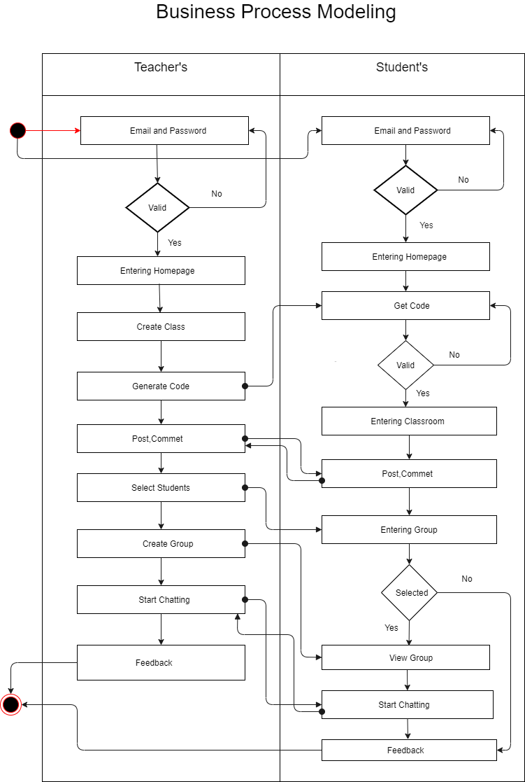

Fig: 3.1 Business Process Modeling

# 3.2 Requirement collection and analysis

Application requirements:

* User
* Continuously update the information
* Time convenience
* User-friendly
* Easily to accessible
* Log in the system for the Admin
* Browser Access
* Get feedback message via user

## 3.2.1Hardware and Software Requirements for Our System

At the very first, you must check the hardware for your computer, user should first make sure that their computer supports the system requirements and ready to operate. These are the necessary specifications that must have in order to use the software and hardware to be used properly, all computer software needs some common hardware components.

In the development area, the system requires for all tools and platforms to perform the new system like

* + - 1. XAMPP (New version will be good)
      2. TEXT editor: Sublime Text Editor
      3. Any browser which supports JavaScript

We have to use some design parts with JavaScript, so if any browser is restricted about java then the design won’t work.

## 3.2.2 Analysis

After we have seen the problem of the old system we make that understand there is a great need to develop a new system like this. We decided to take HTML and CSS as front end and PHP to backend and MYSQL for DB as a solution. Strategy for this problem, because PHP is a server-side scripting language for developing a web-based application and that is peaceful to be developed.

**3.3 Use Case Modeling and Description**

Use Case model is a model that define that how different types of users interact with the system to solve a problem. This model elements are use cases, actors and relationships between actors. In our project there are two actors- Teacher and Student.

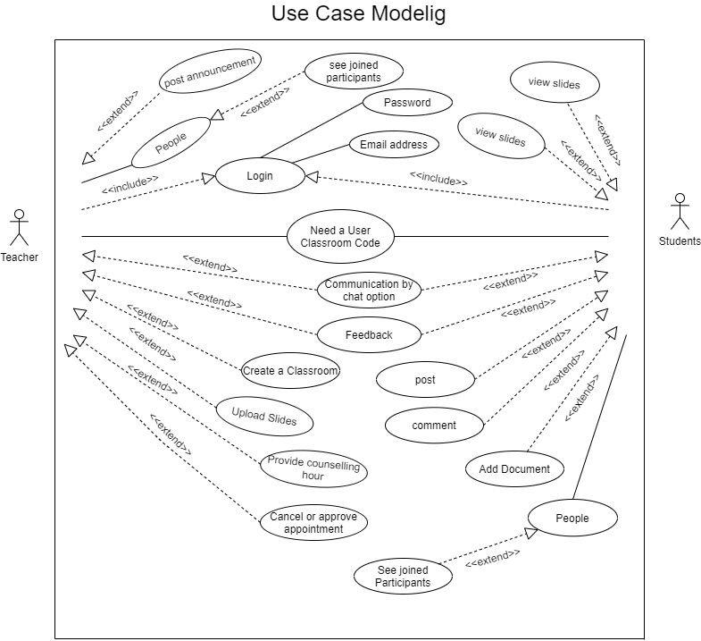

Fig: 3.3 Use Case Modeling

**Description**

**Actor:** Teacher

**Actor:** Student

Main Flow:

* Use case starts when both users enter into the system.
* Teacher can create a classroom, create a group, create a post, and upload slides.
* Students can use the facility of the system. For example- view slides, add

document, create post, comment, join group.

Brief description:

Actor: Teacher

Steps:

* Teacher can log into the system
* Teacher create a class and provide the class code to the students.
* They can Uploads slides.
* Teacher create a group for connect with the students.
* Teacher can make post, comment and add announcement.

Brief description:

Actor: Students

Steps:

* Students also need to log in.
* They can join class which is provided by their teacher.
* They can view slides.
* They can add document, comments.
* Students can join to the group for connecting with their teacher.

**3.4 UML Object Diagram**

UML(Unified Modeling Language) is a diagram which can show a complete or partially view of a structure of a modeled system at a specific time. UML Object diagram use notation and it can capture the static view of a system.

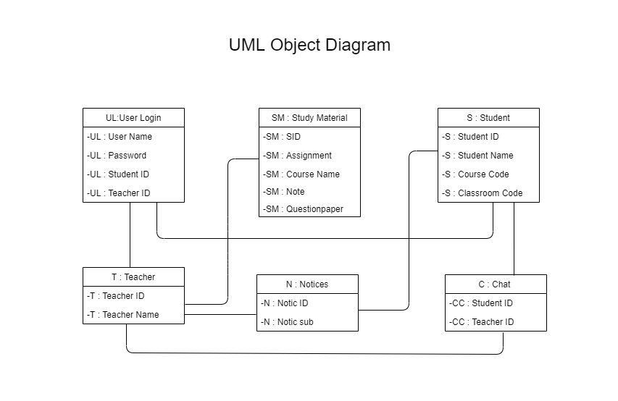

Fig: 3.4 UML Object Diagram

**3.5 Data Flow Diagram**

DFD is a way of representing a flow of data through a system. It also provides the input and output of each entity. Data Flow diagram has no control flow and loops.

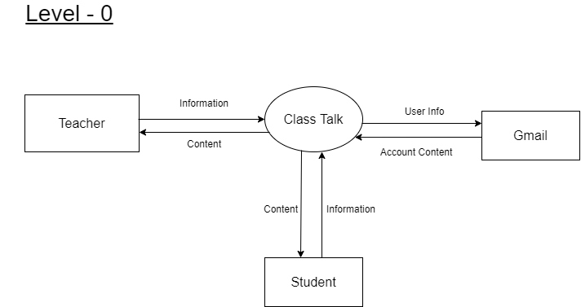

Fig: 3.5 DFD0

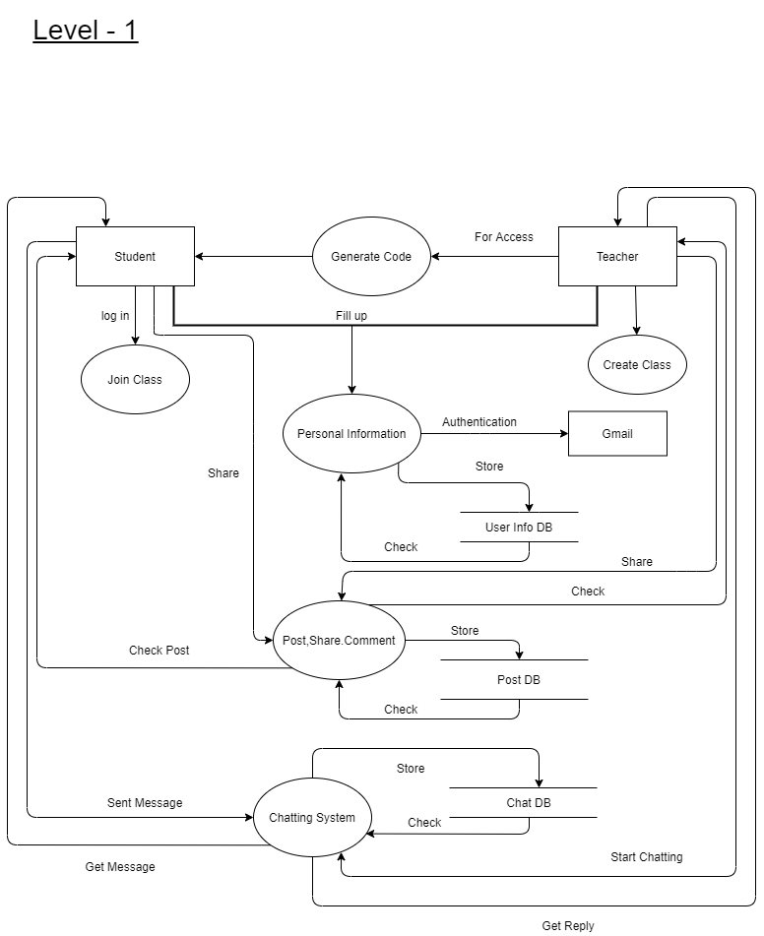

Fig: 3.5 DFD1

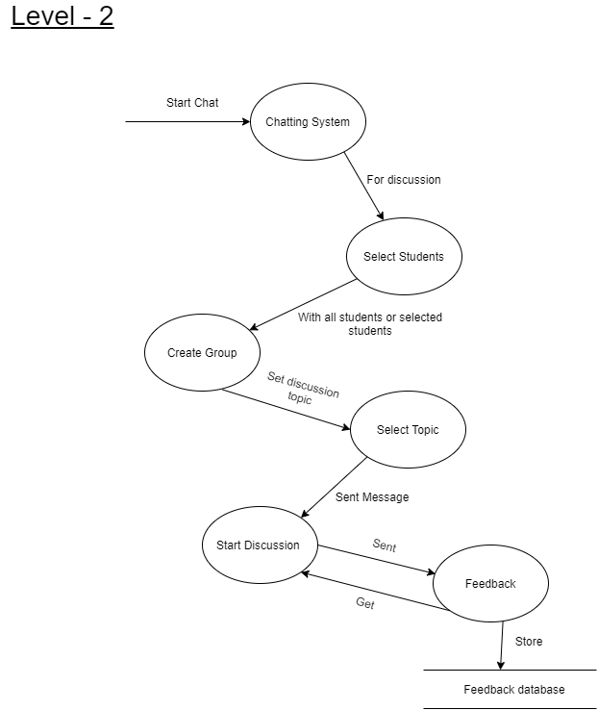

Fig: 3.5 DFD2

**3.6 Activity Diagram**

Activity Diagram is a flowchart which can represent the flow from one activity to another activity. It also can represent the workflows of stepwise activity.

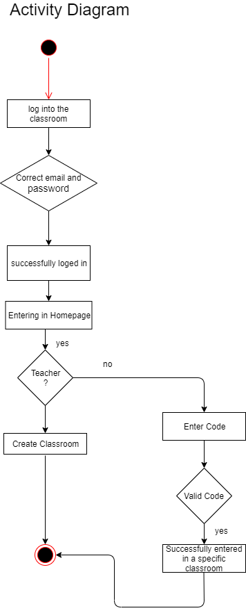

Fig: 3.6 Activity Diagram.

**3.7 Entity Relationship Diagram**

An Entity relationship diagram can describe that how entities are related to each other. It is a framework of a certain business process. ER diagram can describe the structure of data base. An ERD contains different types of symbol.

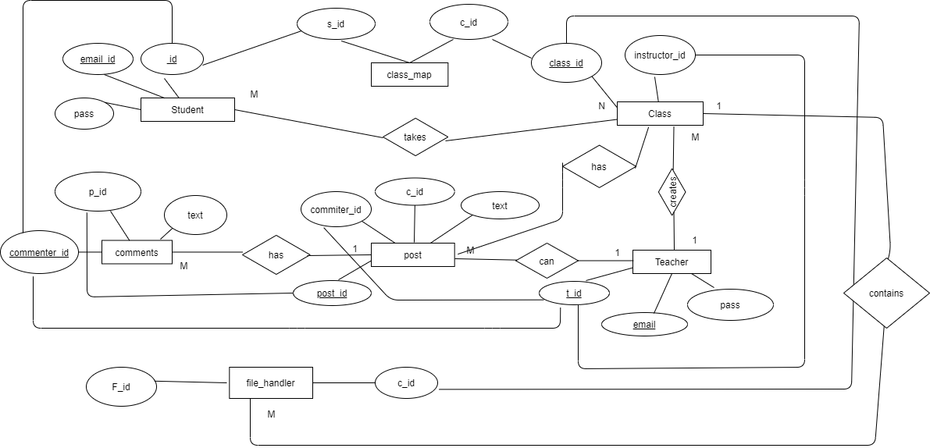

Fig: 3.7 Entity Relationship Diagram

**3.8 Design Requirement**

This step is the most important step of our entire work. Because this is the architecture of our project. As we already talk about BPM, ER diagram, data flow diagram. These are the main pillar of our project how my project is running on the basis. This section tells how our data will be fetched, my pages will be sorted. So, drawing these designs we have used a tool based on online. The name of the tool is draw.io. Where anybody can make diagram depends on their project.

**CHAPTER 4**

**DESIGN SPECIFICATION**

**4.1 Front-End Design**

Front-end Design means that web design is Front part and web development is End part. Consists of these two parts are called front-end design. Front-end design is done by the HTML, CSS and JavaScript code. We use Bootstrap which is a framework of HTML and CSS. The design is visible while using a web application formation of HTML, CSS and JavaScript code. It is controlled desktop or laptop’s browser if the browser supported those languages. Design include some elements those are nav bar, drop-down, forms like login, Insert, Send messages. We use Raw PHP, JavaScript, HTML, CSS, and Bootstrap framework to design our full System.

## 4.1.1 HTML: Hyper Text Markup Language

HTML stands for Hypertext Markup Language and it has a set of markup symbols. It is used to structure a web page and its content by using HTML tags.HTML elements are represented by so many different tags and now html5 version running. Tags label pieces of content like "heading", "paragraph", "table",'' form'' and so many others we used. Browsers only show the content of the tags. It only follows the command, does not display the HTML tags. The markup tells web browsers how to display a web page's words and images and the browser works according to it.

## 4.1.2 Java-Script

JavaScript is a client-side scripting language. It was designed to make web pages interactive and it is a very lightweight programming language.

It is used in website development for such things as adding functions, features, change images, check or modify the contents of forms, detect browsers, dynamically change background colors, open a new window, etc.

## CSS: Cascading Style Sheet

CSS (Cascading Style Sheets) is used to style and layout of web pages. It can be added to HTML pages in three ways: internal, external, and inline styles. For example, to change the font, color, shape, and spacing of content, divide it into multiple columns or add animations in pages, and for other features we need CSS. HTML is used for web page structure and CSS gives it a look by adding different designs, visual effects, and background-color. Its latest version is CSS3.CSS is easy to use and one CSS sheet can be reused in multiple HTML pages [1].

## JQuery

JQuery is an open-source JavaScript library. The main purpose of jQuery is to make easier use of JavaScript on websites. Some important features of jQuery are HTML manipulation, DOM manipulation, DOM element selection, CSS manipulation, Effects, and Animations, Utilities, AJAX, HTML event methods, etc. jQuery takes some common tasks and wraps them into methods that can be used by calling a single line of code.

* + 1. **Bootstrap**

Bootstrap is a very popular front-end framework that includes HTML, CSS, and JavaScript-based design templates. It helps to design responsive websites faster and easier. The latest version is Bootstrap4 and it is free to download and use. We used the bootstrap framework to build our website for mobile responsive. This framework includes forms, buttons, tables, navigation, modals, image carousels, etc. It also supports JavaScript plugins. It also helps to create more lucrative, dynamic, and user-friendly websites.

**4.2 Back-end Design**

## 4.2.1 PHP

PHP stands for Hypertext Preprocessor. It is a server-side scripting language. It is open-source software that means anyone can download and use it for free. PHP supports many databases like MySQL, Oracle, Informix, Solid, PostgreSQL, Generic ODBC, etc. It is great for complex webpage designs.

## MySQL

MySQL is a popular database management system. It helps to manage relational databases using SQL. MySQL is stored in database objects which is called tables. Tables further stores data in rows and columns. It can run on multiple platforms such as Linux, Windows, and Unix.

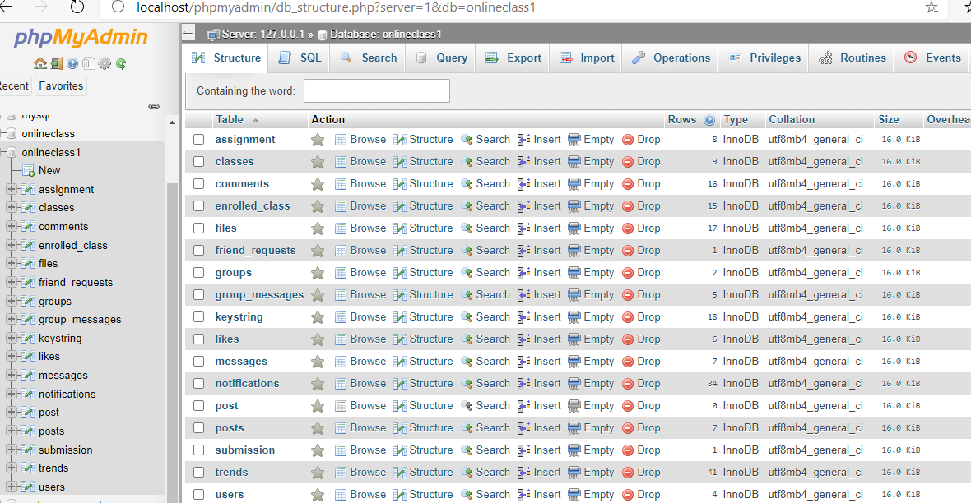

Fig 4.2.2: Database table list

* 1. **Interaction Design and User Experience (UX)**

Our project class talk will be very user friendly because it is based on easy handling features with dynamic options. In this pandemic situation it will be a great site for student to communicate with teachers so easily with a chatting feature. The option is very kind to operate and can easily interact with any kind of user. For easy login we are using Google Auth client where user can login with one click on selecting users. All the design had been designed based on what user wants. So definitely we are expecting that the interaction of users will be satisfying.

* 1. **Implementation Requirements**

We implemented our project with HTML, CSS, Bootstrap, and JavaScript. To implement our project, we need XAMPP for PHP. We use Photoshop for logo designing. For HTML, CSS, JavaScript, implementation we need sublime text.

Software requirements for our application

* + Operating System Windows.
  + SUBLIME or any kind of software that works like sublime.
* And for the server running XAMPP Serve

**CHAPTER 5**

**IMPLEMENTATION AND TESTING**

**5.1 Implementation of Database**



Fig 5.1: Database table list

* 1. **Implementation of Front-end Design**

Front-end Design means that web design is Front part and web development is End part. Consists of these two parts are called front-end design. Front-end design is done by the HTML, CSS and JavaScript code. We use Bootstrap which is a framework of HTML and CSS. The design is visible while using a web application formation of HTML, CSS and JavaScript code. It is controlled desktop or laptop’s browser if the browser supported those languages. Design include some elements those are nav bar, drop-down, forms like login, Insert, Send messages. We use Raw PHP, JavaScript, HTML, CSS, and Bootstrap framework to design our full System.

* + 1. **Homepage of Class Talk**

Our project homepage look is very simple. It contains a login button and a create account button. User can log into our system from homepage. They also can create an account if they need.

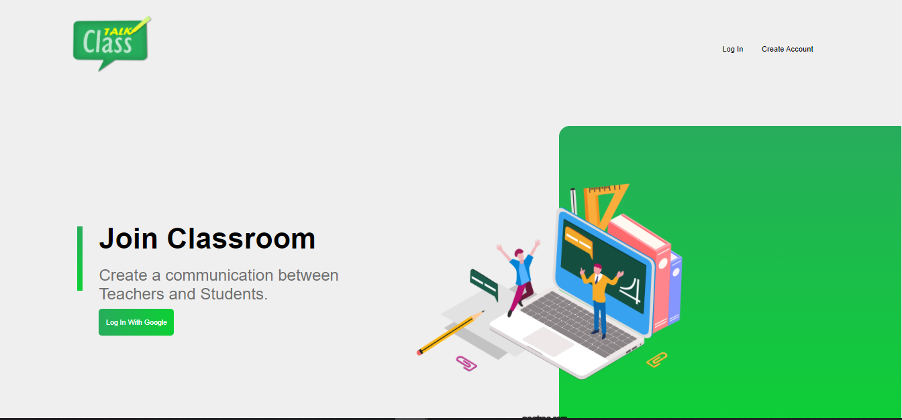

Fig 5.2.1 Homepage

* + 1. **Login with Google**

User can log in to the system with their google account. They can choose an account if they have multiple account. First of all, they need to enter their email address and then need to enter their password.

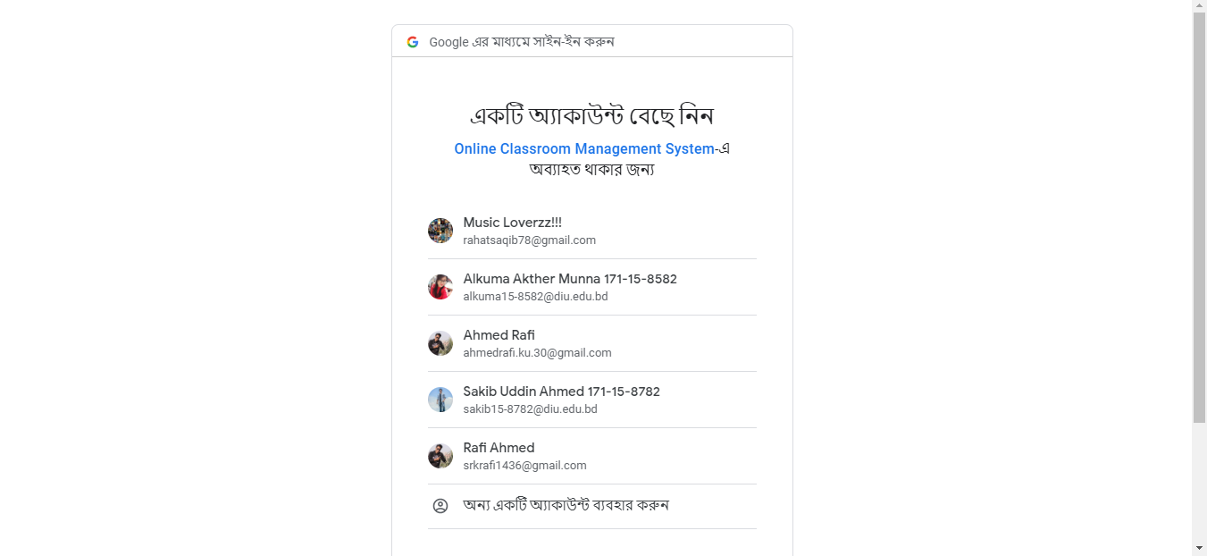

Fig 5.2.2 Google Login

* + 1. **Class List of Class Talk**

In this section students can view their registered classes. For this they need to join in every class.

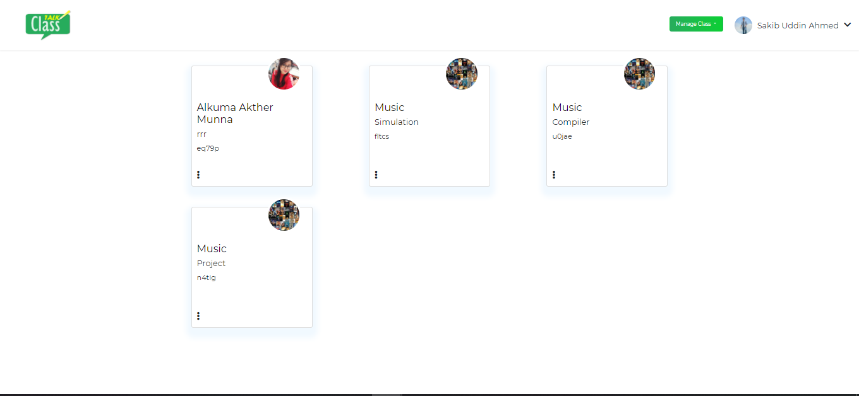

Fig 5.2.3 Class List

* + 1. **Join Class of Class Talk**

Every student needs to join in class. For joining they need a class code. This code will be provided by their course teacher. After getting the code they enter this code in the specific location and click to the submit button.

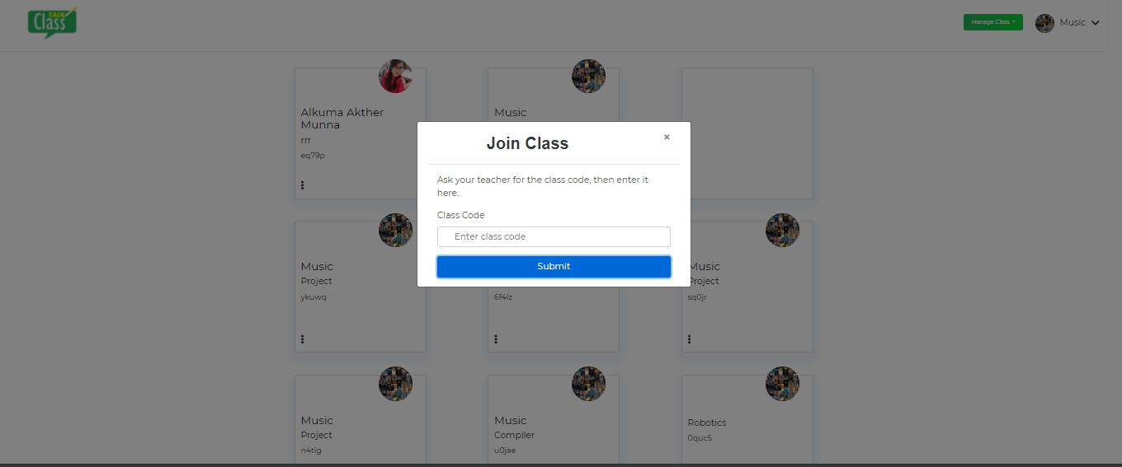

Fig 5.2.4 Join Class

* + 1. **Create Class**

Teachers can create class. For this they need to enter course name, section, and title then click on submit button. After submitting a class code will be generated automatically.

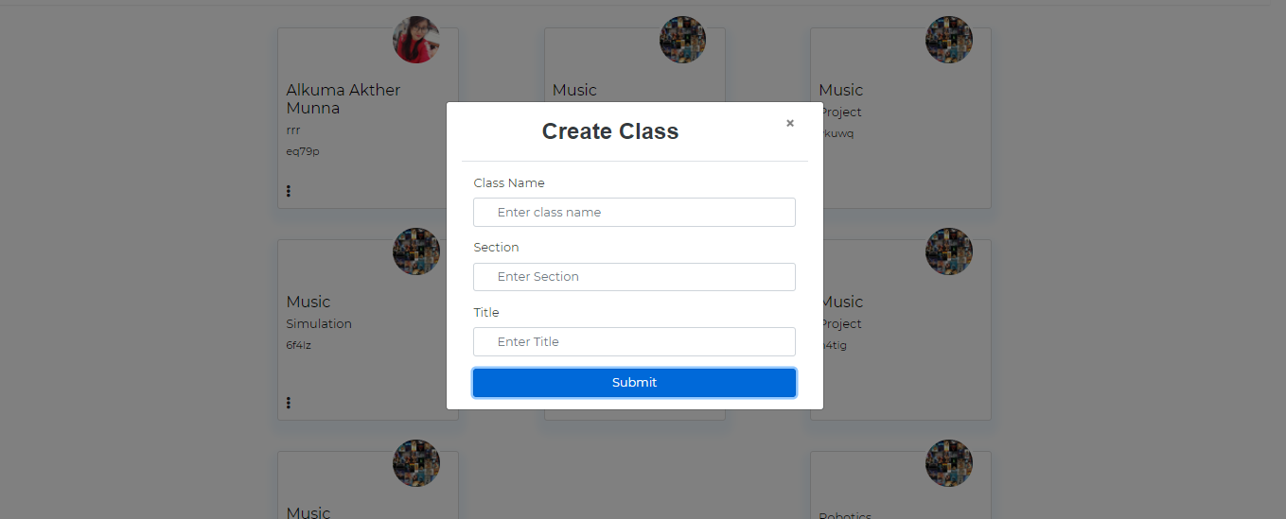

Fig 5.2.5 Create Class

* + 1. **Homepage of class**

In this section students can view their all classes. They can select a specific class from this homepage.

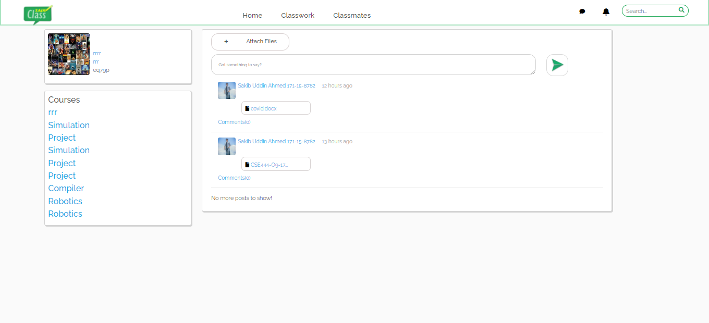

Fig 5.2.6 Homepage of Class

* + 1. **Classwork of Class Talk**

Students can view their task from this section. They also can submit their work which provided by their teacher. They can see the deadline of their work submission.

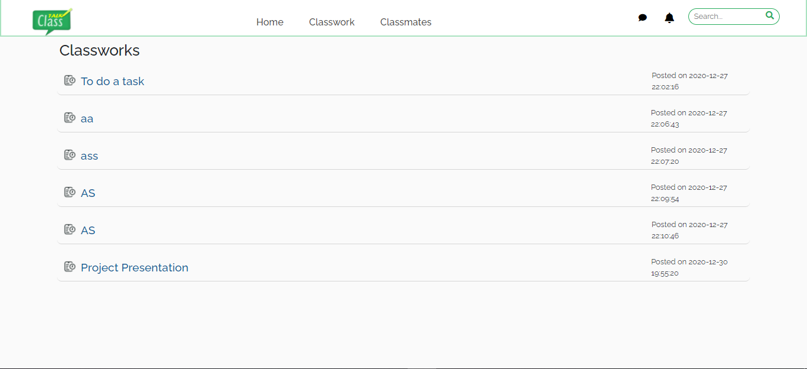

Fig 5.2.7: Classwork

* + 1. **Classmates**

In this part students can view their classmates list. If anyone miss to join class then their classmates will inform them to join the class.

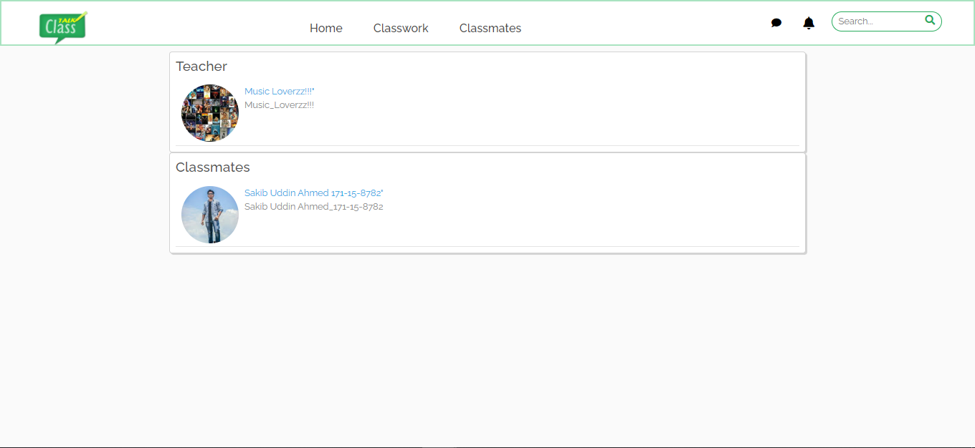

Fig 5.2.8 Classmates

* + 1. **Classmate Profile**

Every student can view their classmates’ profile by this section. It is helpful for those students who want some information about their classmates.

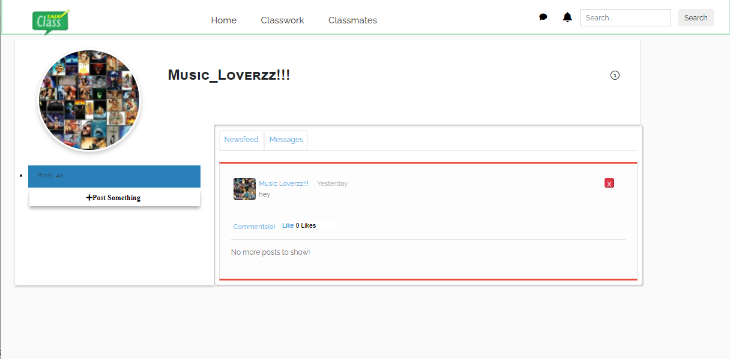

Fig 5.2.9 Classmate Profile

* + 1. **Message with students & teachers**

It is our projects special feature. Here student and teacher can communicate together through messaging.

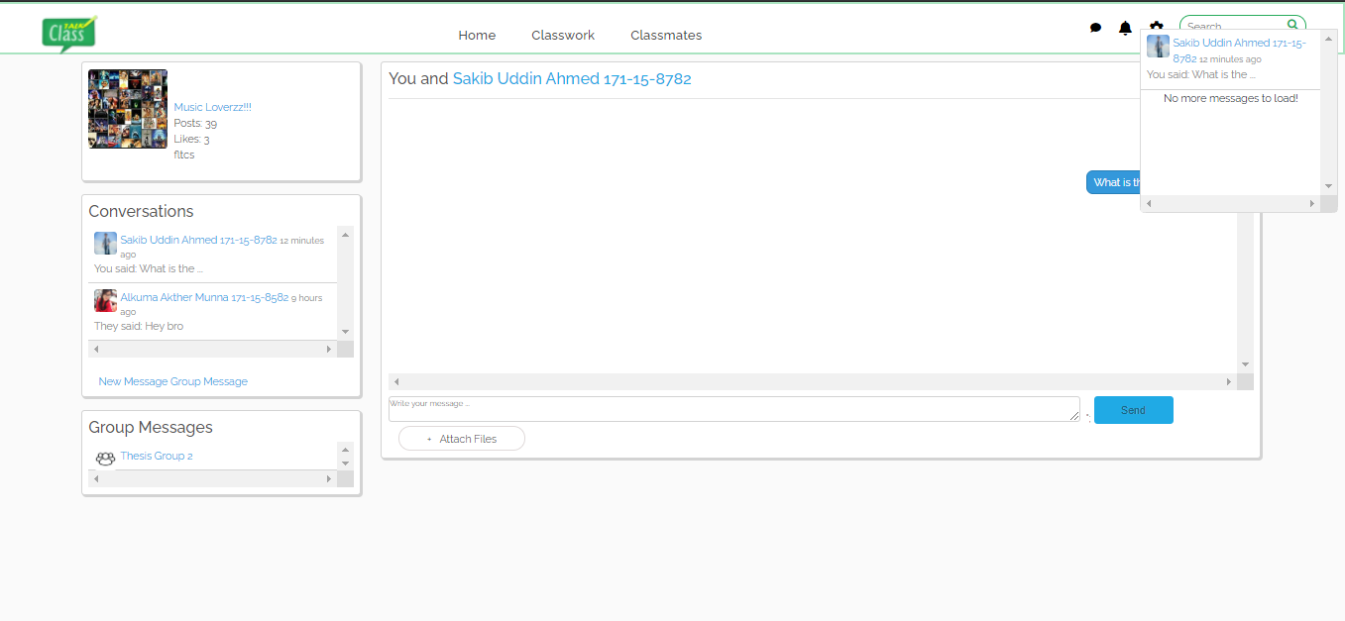

Fig 5.2.10 Messaging

* + 1. **Submit Class Assignment**

Students can submit their assignment by this section. They can attach different types of file such as PDF, Doc file, Text file etc. They also can submit multiple file at a time.

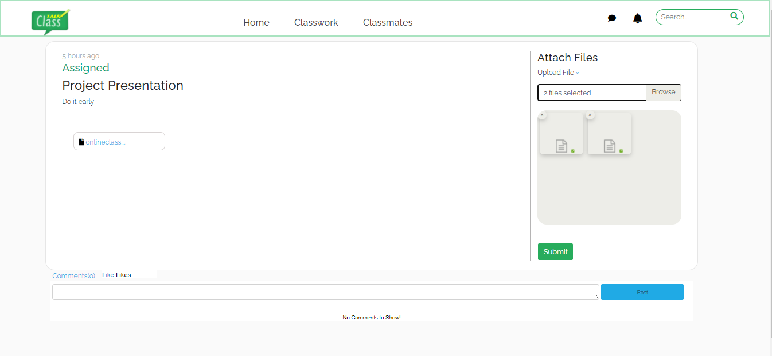

Fig 5.2.11 Submit Assignment

* + 1. **Create Assignment by teacher**

Teacher can create assignment. They can fix deadline of an assignment. For creating an assignment, they need to enter assignment title, instructions and date.

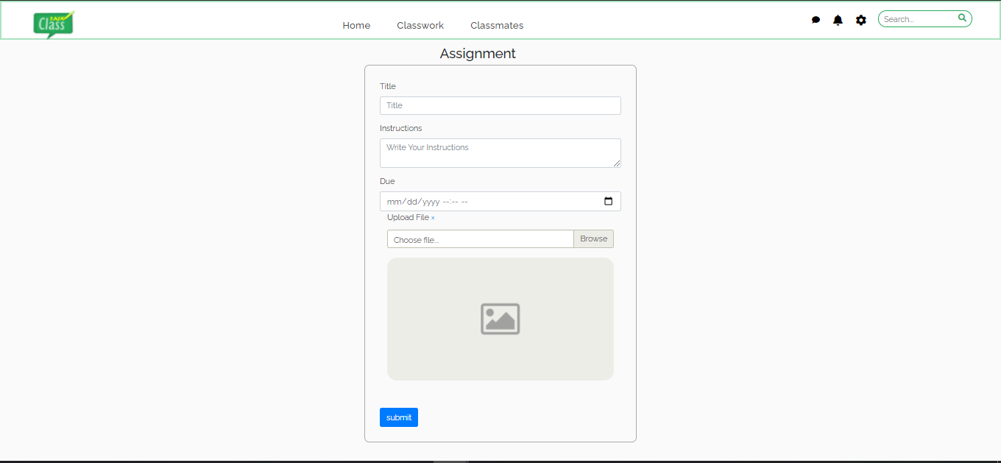

Fig 5.2.12 Create Assignment

* + 1. **View assignment**

Students can view their assignment which is provided by their course teacher.

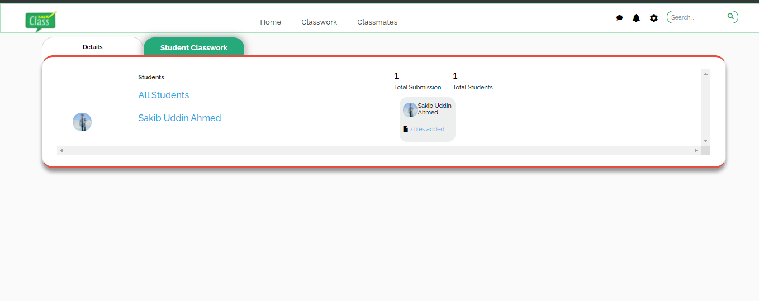

Fig 5.2.13 View Assignment

* + 1. **Grading system of Class Talk**

In this section teacher can upload their students’ grade and marks.

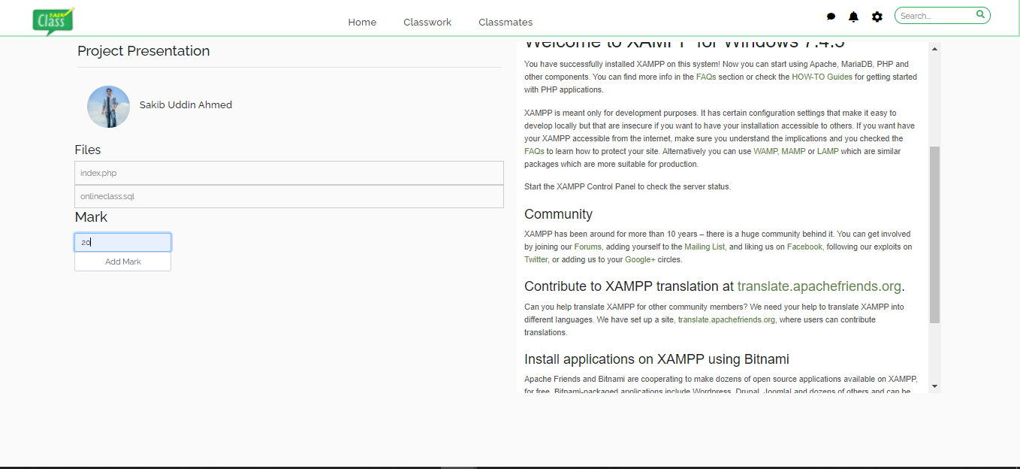

Fig 5.2.14: Grade system of Class Talk

* + 1. **Create Group by teachers**

Teachers can create group with their students. Students can solve their confusion in this group.

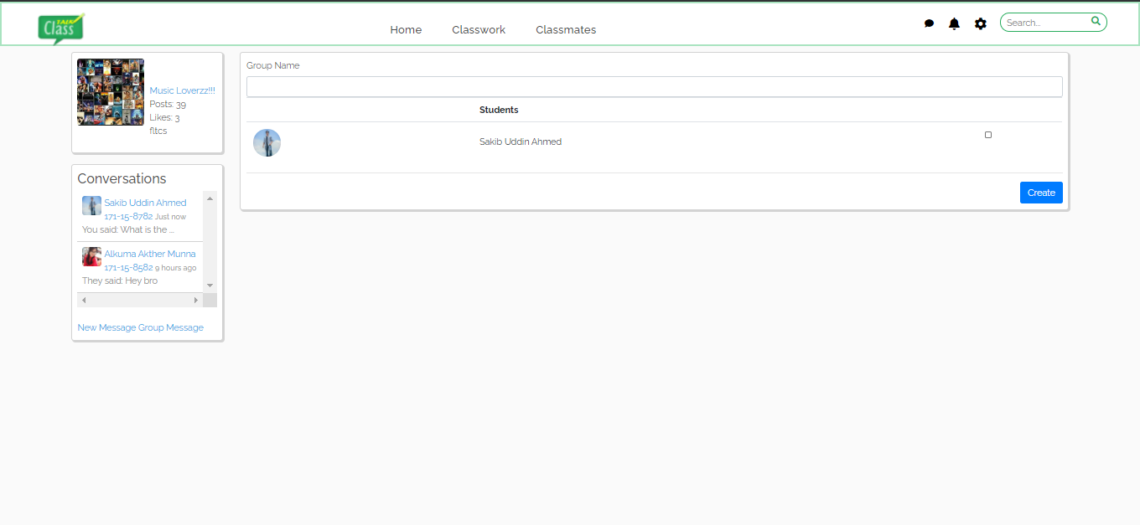

Fig 5.2.15 Create Group

* + 1. **Class Details**

Students and teacher both can view the class details in this section.

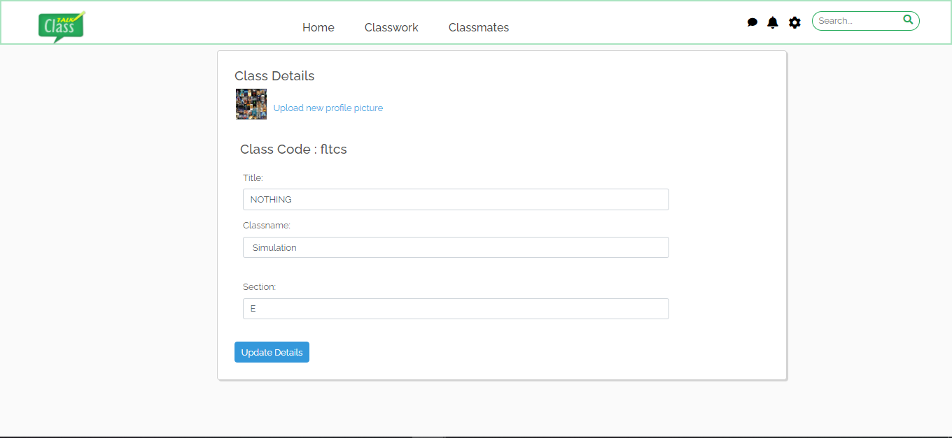

Fig 5.2.16 Class Details

**5.3 Testing Implementation**

We have tested our system by login as teacher and students, create class, join class, create group, add comment, create post, sending messages.

We have tasted these-.

* Both users Log into the system.
* Create class.
* Upload slides
* Create post and group.
* Join class.
* Add document
* View class details.
* Send messages.
* Logout.

**5.4 Test Results and Reports**

We tested our implemented code in Google chrome browser.

**CHAPTER 6**

**IMPACT ON SOCIETY, ENVIROINMENT AND SUSTAINABLITY**

**6.1 Impact on Society**

Online Class Talk has some impacts on society. When taking an online course, Students can take it from the comfort of their own home. No need to get up early and get ready for school, College or University. They can simply complete the course on their own time and setting. It gives students a better start with virtual simulations and models. Teachers are able to communicate with their students virtually. Chatting system of this project allow students to communicate with others.

But excessive technology use can negatively impact on students physical, mental, emotional and social.

**6.2 Impact on Environment**

Our project ensures students education from anywhere. This is beneficial for those people who lives in rural area far from their educational institutions, work full-time, responsible for young children or move frequently for their job. It also removes the necessity of driving to campus. Students can take classes from the comfort schedule of their own home. Using this project, it can save trees and papers. Students paper consumption will decrease significantly.

**6.3 Ethical Aspects**

**Our system is work for everyone**

* We develop inclusive forms
* We test our system with real users
* Prioritize accessibility

### Our application is work on everywhere

* + We built it responsively
  + It is value performance
  + It is expose permanent, human readable, deep links

### Our application will respect all user's privacy and security

* + We use https everywhere
  + It respects user tracking preferences
  + Our application provide users with clear information about how their information is used
  + It allows users to export their data
  + It also Secure user data

### We considerate of our peers

* + We provide comment and document code
  + We tested our code
  + We make uses of source control and continuous integration
  + We contribute to the open source when possible
  + We treat other developers with respect
  + We offer, follow, and enforce a code of conduct for open source projects

**6.4 Sustainability Plan**

**For sustainable plan:**

* We optimize images to reduce file size.
* We use lazy load for images and media.
* We deleted some files what we don't need.
* We improve our sites navigation to make it easy to find information.

**CHAPTER 7**

**CONCLUSION AND FUTURE SCOPE**

**7.1 Discussion and Conclusion**

This project is an exciting topic to work on. After going through the work, we faced many challenging tasks that are related to our educational system. We researched so many web applications that showed us the direction of how to develop our system. We interact with the teacher and students about what type of problems they are facing. They were happy to know as it will save time and they will be able to attend an online class. They don’t need to meet their teachers physically. For everything we achieved, we faced many problems and challenges to finish this project. After all, it’s an online-based system. The opportunities provided through this web application is huge.

**7.2 Scope for Further Developments**

The current situation does not provide an internet registration system. The only service available on the internet is the organization of the schedule of the student for the incoming semester, without any sort of official version of the schedule. The student still must go to his advisor’s office, talk his schedule over with him, get it approved and signed, then take the approved schedule to the registrar’s office to be officially signed in. The scope of this project is not much beneficial for a developer but it’s very beneficial for the new generation. Students nowadays showing interest in an easier life lead and want everything possible on the internet. From their perspective, we are building this project. Especially we include a chatting system and a counseling hour behind sharing a post. It helps students to develop their study. Whom are don’t feel free to communicate with teachers can easily solve their problem with a counseling hour through chat. It will create a huge space for students to share anytime with teachers by chatting. They can get their lectures online.

**REFERENCES**

1. S. Wang, L. L. Minku, and X. Yao, “Resampling-Based Ensemble Methods for Online Class Imbalance Learning,” IEEE Transactions on Knowledge and Data Engineering, vol. 27, no. 5, pp. 1356–1368, 2015.
2. J. Lee, “A case study of collaborative learning implementation using open source Moodle learning management system - for collaborative learning promotion by users –”, Journal of Service Research and Studies, vol. 6, no. 4, pp. 47-57, 2016.
3. Z. Yang and Q. Liu, “Research and development of web-based virtual online classroom”, Computers & Education, vol. 48,no.2, pp. 171-184, 2007.
4. V. Bradley, “Learning Management System (LMS) Use with Online Instruction”, International Journal of Technology in Education, vol. 4, no. 1, p. 68, 2020.
5. Rabiman, R., Nurtanto, M., & Kholifah, N, “Design And Development E-Learning System By Learning Management System (LMS) In Vocational Education”, INTERNATIONAL JOURNAL OF SCIENTIFIC & TECHNOLOGY RESEARCH, vol. 9, pp. 1059-1063, January 2020.
6. Z. Khusnul, F. Helmanto, N. Maryani, “The Practice of Effective Classroom Management in COVID-19 Time”, International Journal of Advanced Science and Technology , vol. 29, pp. 3263-3271, 2020.
7. Scribd.com, 2021. [Online]. Available: https://www.scribd.com/doc/59220739/SRS-documentation-of-Virtual-Classroom-System-SRS-documentation-of-Personal-Identity-Management-SRS-documentation-of-EMentoring-for-women-system. [Accessed: 08- Nov- 2020].
8. academia.edu,“Software Requirements Specification For Online Training Application”, Academia.edu,2021.[Online].Available:https://www.academia.edu/15823029/Software_Requirements_Specification_For_Online_Training_Application. [Accessed: 19- Nov- 2020].
9. Web.wpi.edu, 2021. [Online]. Available: https://web.wpi.edu/Pubs/E-project/Available/E-project-050118-070149/unrestricted/EduLinkUserGuide.pdf. [Accessed: 10- Jan- 2021].
10. L. Main, “Web-based virtual classrooms: a model for LIS education”, Education for Information, vol. 16, no. 4, pp. 333-340, 1998. Available: 10.3233/efi-1998-16403.
11. R. M.M, A. S.O and A. O.A.S, "A Conceptual Model for Virtual Classroom Management", International Journal of Computer Science, Engineering and Information Technology, vol. 5, no. 1, pp. 27-32, 2015.
12. A. Osman, Learning management systems (LMS). Saarbrücken: LAP Lambert Academic Publishing, 2010.
13. G. Naveh, D. Tubin and N. Pliskin, "Student LMS use and satisfaction in academic institutions: The organizational perspective", The Internet and Higher Education, vol. 13, no. 3, pp. 127-133, 2010.
14. Gabriel, M. , “Learning together: Exploring group interactions online”,Journal of Distance

Education, vol 19, pp : 54-72, 2004 .

1. “Pros and cons of Google Classroom”, Uft.org, 2021. [Online]. Available: https://www.uft.org/news/teaching/linking-learning/pros-and-cons-google-classroom. [Accessed: 29- Dec- 2020].
2. N. Lin, “10 Exciting New Google Classroom Features”, EdTechReview, 2021. [Online]. Available: https://edtechreview.in/trends-insights/trends/2902-10-exciting-new-google-classroom-features. [Accessed: 06- Oct- 2020].
3. “Learning management system”, En.wikipedia.org, 2021. [Online]. Available: https://en.wikipedia.org/wiki/Learning_management_system. [Accessed: 06- Oct- 2020].
4. “5 Discussion Ground Rules for the Online Classroom”, CSU Online ValuED Blog, 2021. [Online]. Available: http://blog.online.colostate.edu/blog/online-teaching/5-discussion-ground-rules-for-the-online-classroom. [Accessed: 10- Oct- 2020].